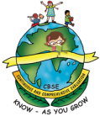

GREENWOOD PUBLIC SCHOOL
ADITYAPURAM, GWALIOR
SESSION 2026-27 : SYLLABUS FOR THE MONTH OF APRIL : CLASS-NURSERY
SUBJECTS | SYLLABUS | ACTIVITY + USE OF ICT | PARENTS INVOLVEMENT
ENGLISH  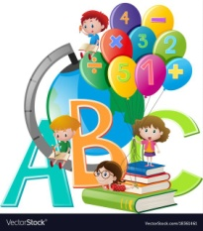  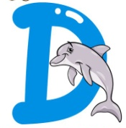  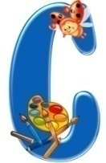  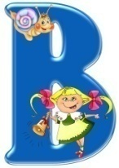  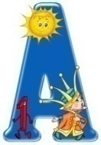 | ORAL:  Rhymes-  1. Johny-Johny…  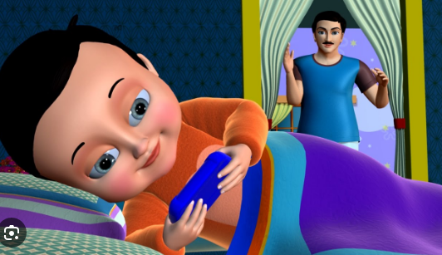  2. Twinkle-Twinkle…  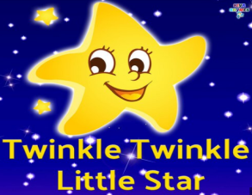  Sentence Structure- I am a boy/girl.  Vocabulary Building-  Pencil, Eraser, School Bag, Book, Bottle, Sharpener, Lunch Box, Pencil Box  Recognition- A, B, C, D  WRITTEN:  Practicing Strokes- Standing lines, Sleeping lines, Slanting lines  Workbook- Page no. 2, 3 | Rhymes-  1. Johny-Johny…  https://youtu.be/EA_fbT6oN2k?feature=shared  2. Twinkle-Twinkle…  https://youtu.be/yCjJyiqpAuU?feature=shared  Phonics Sound  https://www.youtube.com/watch?v=hq3yfQnllfQ  Alphabet Song  https://www.youtube.com/watch?v=zAlX1V3lK5s  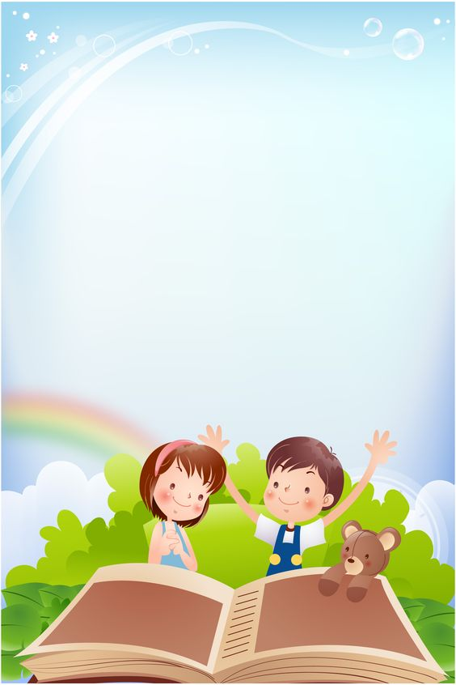  Activity Work  - ‘Look and Identify’ Game will be played for the recapitulation of the letters and their related objects. Learners will be asked to look and identify the objects as shown by the teacher.  - ‘Show and Tell’ Picture Reading Activity | - Play music and encourage your child to dance around. When the music stops, call out a word that rhymes with a simple action (e.g., "twinkle" and "papa"). Children freeze in place and perform the action associated with the rhyming word.  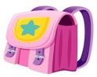  Vocabulary Building-    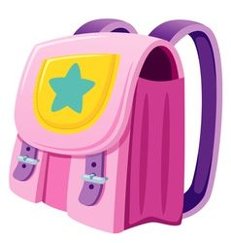  School Bag,  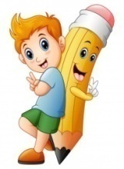  Book,    Pencil,  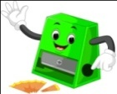  Eraser,  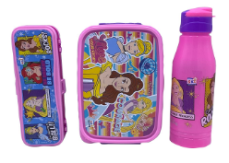  Sharpener  Bottle  Lunch Box  Pencil Box

SUBJECTS | SYLLABUS | ACTIVITY + USE OF ICT | PARENTS INVOLVEMENT
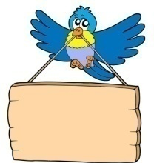  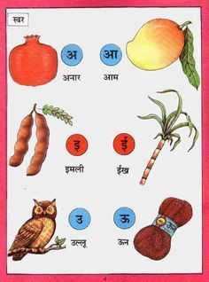  HINDI | ekSSf[kd%&  dfork,¡&  1- eNyh    2- eksVw jke  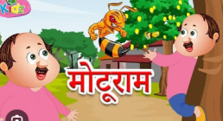  Loj o.kZ& v ls bZ rd  okD; jpuk& eSa ,d yM+dk@yM+dh gw¡A  v{kjksa dh igpku& v ls bZ rd  fyf[kr%&  lajpuk&js[kk,sa  v{kj ys[ku& ist ua- 3] 4 | dfork,¡&  1- eNyh  https://youtube.com/watch?v=4nvBAAl3RvY&feature=shared  2- eksVw jke  https://www.youtube.com/watch?v=p_F9yp4NmJs&list=RDp_F9yp4NmJs&start_radio=1  Loj o.kZekyk xhr  https://www.youtube.com/watch?v=TM83zp1AkUM  Activity work  - dforkvksa dks lLoj okpu  - Þns[kks vkSj crkvksaÞ [ksy ls fp=ksa dks igpkudj crk,¡A | - cPpksa dks Lojksa ls lacaf/kr fp=@oLrq,¡ igpkuusa esa lgk;rk djsaA  - cPpksa dks dfork fofHkUu Hkkoksa rFkk eqnzkvksa lfgr ;kn djkus ds fy, çksRlkfgr djsaA
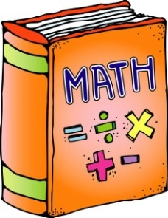 | ORAL:  1. Counting from 1-5  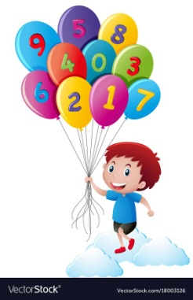  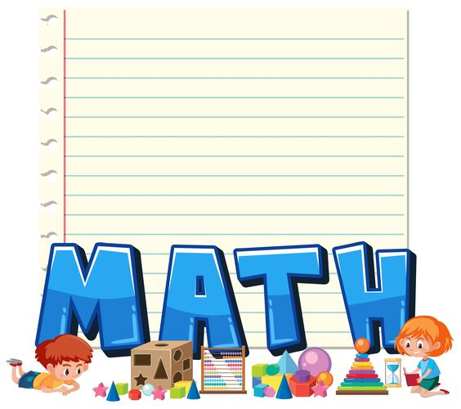  WRITTEN:  Standing lines,  Sleeping lines,  Slanting lines  Workbook-  Page no. 5, 6, 7, 8 | Counting Song  https://www.youtube.com/watch?v=JT0MmZcJ2Vw  Activity Work  - ‘Look and Identify Number’ Game.  - Learners will be asked to count the objects asked by the educator. | - Provide a variety of toys or objects (e.g., blocks, stuffed animals). Ask your child to count the toys, group them by number, or sort them into containers labeled with numbers.

SUBJECTS | SYLLABUS | ACTIVITY + USE OF ICT | PARENTS INVOLVEMENT
ART & CRAFT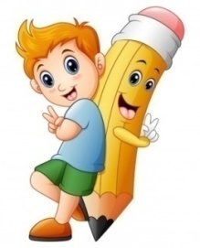 | Page no. 2, 3  Craft- Finger Printing, Cotton Dabbing (Theme-Any Shape) | Introduction to Shapes through “Shapes song”  https://www.youtube.com/watch?v=QBD7CB-rroo  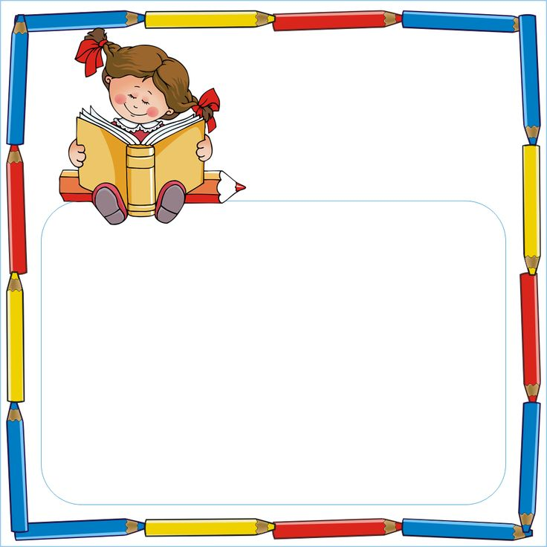  Activity Work  - ‘Look and Identify’ Shapes Game  - ‘Cut and Paste’ Game of different objects. | - Provide play dough and shape cutters in various shapes (e.g., circles, squares, triangles). Encourage your child to roll out the play dough and use the cutters to make shapes.
GENERAL KNOWLEDGE | Fruits- Apple, Mango, Grapes, Banana, Orange, Papaya | Fruits Names  https://www.youtube.com/watch?v=ltQvxxicnQM  Activity Work  - Make a fruit chart pasting the  pictures of fruits. | - Take your child to a fruit market and ask him/her to point out the fruits.
VALUE EDUCATION | I love my parents. | Moral Story- The Elephant and The Ants  https://youtu.be/RijUCPIVOSU?feature=shared | - Make your child learn the names of family members.
PHYSICAL EDUCATION | Fun Games- Running, Jumping, Hopping | DO EXERCISE THROUGH THIS LINK  https://www.youtube.com/watch?v=JoF_d5sgGgc | - Take your child to a park and play some games.
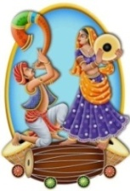  DANCE | 1. Welcome Song,  2. Deep Deep Deep | 1. Welcome Song  https://youtu.be/Iskpu8586Ek?si=LQgyxxdoKR60PT8Y  2. Deep Deep Deep  https://youtu.be/oZhwagxWzOc?feature=shared | - Encourage your child to move specific body parts independently, such as wiggling fingers or shaking hips.
MUSIC | National Anthem, Gayatri Mantra | National Anthem  https://www.youtube.com/watch?v=RqQ4asI70Bg  Gayatri Mantra  https://www.youtube.com/watch?v=SPm-Qy5m39E  Hanuman Chalisa  https://www.youtube.com/watch?v=iI77p-PPAxs | - Practice the prayer regularly with your child to memorize it.
MOTOR SKILL DEVELOPMENT | 1. How to do Namaste  2. How to walk in a straight line  3. How to sit gracefully on the chair  4. How to use the washroom and wash hands | REFER THIS LINK  https://www.youtube.com/watch?v=wh6gt3IkRKk | - Encourage your child to run around in open spaces, either indoors or outdoors.
LANGUAGE DEVELOPMENT | Action words: Writing, Eating, Jumping, Running and Drinking. | Good Habits  https://youtu.be/mbv63Lz2vAw?feature=shared | - Make your child learn the name of school.
S.T.E.M. Fun | Melting Ice:  - Materials: Ice cubes, salt, small plastic toys  - Procedure: Place ice cubes in a container and sprinkle salt over some of them. Encourage children to observe and compare how the ice cubes melt with and without salt. Add small plastic toys to the ice cubes and observe how the melting ice affects them.

SUBJECTS | SYLLABUS | ACTIVITY + USE OF ICT | PARENTS INVOLVEMENT
CONVERSATION | ENGLISH CONVERSATION  1. What is your name?  Ans. My name is .  2. How are you?  Ans. I am fine, thank you.  3. How old are you?  Ans. I am 3 years old. | HINDI CONVERSATION  1- vkidk D;k uke gS\  m& esjk uke gSA  2- vki fdrus o’kZ ds gSa\  m& eSa rhu o’kZ dk gw¡A  3- vki dSls gS\  m& eSa vPNk@vPNh gw¡A | - Pay close attention to your child when he/she speaks, and respond with interest and enthusiasm. Ask open-ended questions and let the child respond.
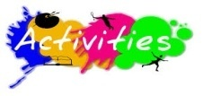 | 10th April- Baisakhi Celebration,  22nd April- Earth Day Celebration- Leaf Printing
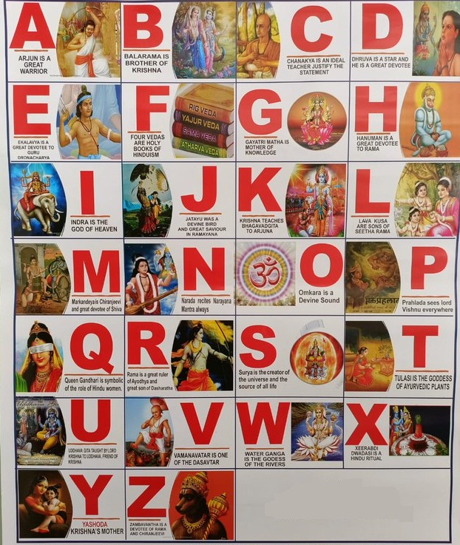
ALPHABETS

GREENWOOD PUBLIC SCHOOL
ADITYAPURAM, GWALIOR
SESSION 2026-27 : SYLLABUS FOR THE MONTH OF APRIL : CLASS-LKG
SUBJECTS | SYLLABUS | ACTIVITY + USE OF ICT | PARENTS INVOLVEMENT
ENGLISH | ORAL:  Rhymes-  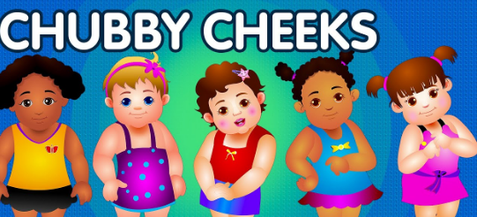  1. Chubby Cheeks  2. Hop a Little, Jump a Little  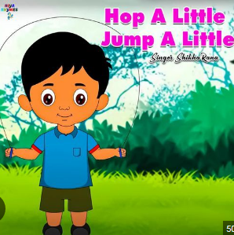  Reading- Picture Talk, The Alphabets (A-Z)  Vocabulary Building- Chair, Table, Bench, Chalk, Duster, Green board Educomp  WRITTEN:  Capital Letters (A-Z), Match the following, Write the missing letters, Circle the correct letter for the given pictures, Write the first letter of the picture,  Dictation | Rhymes-  1. Chubby Cheeks  https://youtu.be/InjAIlwpdCQ?feature=shared  2. Hop a Little, Jump a Little  https://www.youtube.com/watch?v=FTJchtcnZm8&list=RDFTJchtcnZm8&start_radio=1  Phonics Sound  https://www.youtube.com/watch?v=hq3yfQnllfQ  Alphabet Song  https://www.youtube.com/watch?v=zAlX1V3lK5s  Vowels Song  https://www.youtube.com/watch?v=RUSCz41aDug  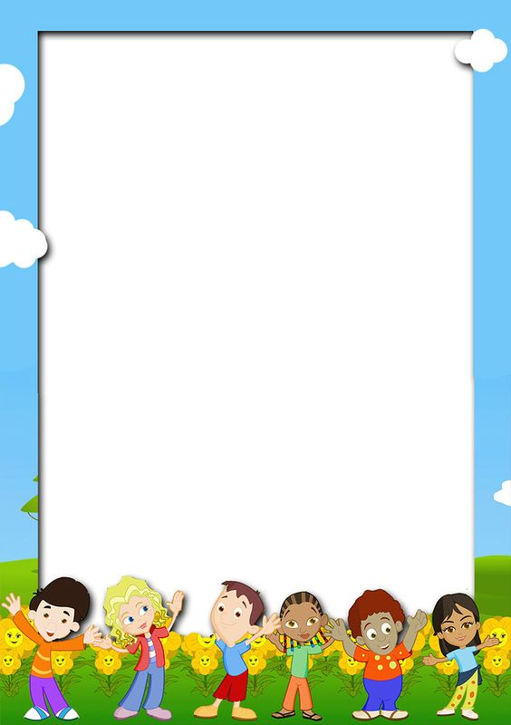  Activity Work  - ‘Look and Identify’ Game will be played for the recapitulation of the letters and their related objects. Learners will be asked to look and identify the objects as shown by the teacher.  - ‘Show and Tell’ Picture Reading Activity |   - Play music and encourage your child to dance around. When the music stops, call out a word that rhymes with a simple action (e.g., "Chubby" and "Hop a Little, Jump a Little"). Children freeze in place and perform the action associated with the rhyming word.
SUBJECTS | SYLLABUS | ACTIVITY + USE OF ICT | PARENTS INVOLVEMENT
HINDI | ORAL:  dfork,¡&  1- losjk 2- vPNs cPps  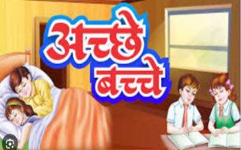  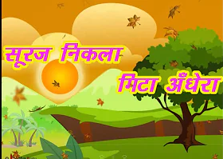  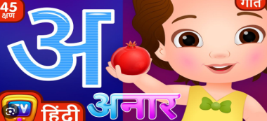  3- Loj xhr  iBu&ikBu o.kZekyk& Loj ¼v ls v% rd½ vkSj O;atu o.kZ ¼d ls M+ rd½] 'kCndks'k]  ist ua 4 ls 10 rd  WRITTEN:  o.kZekyk& Loj ¼v ls v% rd½ vkSj O;atu d ls M+ rd fyf[k,] fp= igpkudj mlds uke dk igyk v{kj fyf[k,] js[kkvksa dk vH;kl dhft,] tksM+h feykb,] Jqrys[k] 'kCn lqys[k ist ua 3&11 | dfork,¡&  1- losjk  https://www.youtube.com/watch?v=N2x3V-8CCzA  2- vPNs cPps  https://www.youtube.com/watch?v=VQcF0B5XE-8  3- Loj xhr  https://www.youtube.com/watch?v=TM83zp1AkUM&list=RDTM83zp1AkUM&start_radio=1  o.kZekyk  https://www.youtube.com/watch?v=GBWGNvHsiFs    Activity Work  - dforkvksa dks lLoj okpu  - ns[kks vkSj crkvksaÞ [ksy ls fp=ksa dks igpkudj crk,¡A  - ^ns[kksa vkSj crkvks* [ksy ds tfj, o.kksaZ dks igpkub, ,oa crkb,sA | - cPpksa dks Loj o.kksZa ls lacaf/kr fp=@oLrq,¡ igpkuusa esa lgk;rk djsaA  - cPpksa dks dfork fofHkUu Hkkoksa rFkk eqnzkvksa lfgr ;kn djkus ds fy, çksRlkfgr djsaA
 | 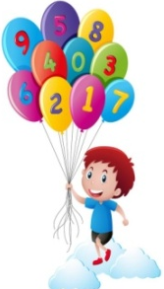  ORAL:  Counting- 1 to 30,  Table of 2, Picture Talk  and Pre Number Concepts,  Shapes  WRITTEN:  Counting from 1 to 30,  Match the following, What comes after, Write the missing numbers, Count and Write, Circle the correct number, Dictation, Numeracy Skill Book Pg no. 4 to 8 | Counting-  https://www.youtube.com/watch?v=B5iAW-jnkPw  Table of 2-  https://www.youtube.com/watch?v=VKJ9cCQgPdc  ACTIVITY WORK  - Look and Identify Number Game.  - Learners will be asked to count the objects asked by the educator. | - Provide a variety of toys or objects (e.g., blocks, stuffed animals). Ask your child to count the toys, group them by number, or sort them into containers labeled with numbers.

SUBJECTS | SYLLABUS | ACTIVITY + USE OF ICT | PARENTS INVOLVEMENT
ART &  CRAFT  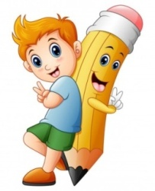 | Book Page no. 4 and 5  (Different Shapes, Fish)  Craft- Origami Cat  (Theme-Shapes) | Introduction to Shapes through “Shapes song”  https://www.youtube.com/watch?v=QBD7CB-rroo  Activity Work  - ‘Look and Identify’ Shapes Game  - ‘Cut and Paste’ Game of different objects. | - Provide playdough and shape cutters in various shapes (e.g., circles, squares, triangles). Encourage your child to roll out the playdough and use the cutters to make shapes.
GENERAL KNOWLEDGE | Unit-1:  All about me,  Body Parts,  Sense Organs | Parts of the body  https://www.youtube.com/watch?v=SUt8q0EKbms  Activity Work  - ‘Cut and Paste’ Game through the pictures of Healthy & Unhealthy food. | - Sit in front of a mirror with your child and take turns mimicking each other's movements. Encourage them to point to and name the body parts they are moving.
VALUE EDUCATION | Always Speak the Truth | Moral Story- The Elephant and The Ants  https://youtu.be/RijUCPIVOSU?feature=shared | - Make your child learn the names of family members.
PHYSICAL EDUCATION | Fun Games- Running, Jumping, Hopping | DO EXERCISE THROUGH THIS LINK  https://www.youtube.com/watch?v=JoF_d5sgGgc | - Take your child to a park and play some games.
DANCE | 1. Welcome Song,  2. Deep Deep Deep | 1. Welcome Song  https://youtu.be/Iskpu8586Ek?si=LQgyxxdoKR60PT8Y  2. Deep Deep Deep  https://youtu.be/oZhwagxWzOc?feature=shared | - Encourage your child to move specific body parts independently, such as wiggling fingers or shaking hips.
MUSIC | National Anthem, Gayatri Mantra | National Anthem  https://www.youtube.com/watch?v=RqQ4asI70Bg  Gayatri Mantra  https://www.youtube.com/watch?v=SPm-Qy5m39E  Hanuman Chalisa  https://www.youtube.com/watch?v=iI77p-PPAxs | - Practice the prayer regularly with your child to memorize it.
MOTOR SKILL DEVELOPMENT | 1. How to do Namaste?  2. How to walk in a straight line?  3. How to sit gracefully on the chair?  4. How to use the washroom and wash hands? | REFER THIS LINK  https://www.youtube.com/watch?v=wh6gt3IkRKk | - Encourage your child to run around in open spaces, either indoors or outdoors.
LANGUAGE DEVELOPMENT | Classroom, Smart Board, Chair, Table, Teacher, School, Pick up the book, Put it on the table, Put it in your bag | Good Habits  https://youtu.be/mbv63Lz2vAw?feature=shared | - Encourage your child in role-playing activities with action words like "fly like a bird," "roar like a lion," "swim like a fish," and "crawl like a bug."

SUBJECTS | SYLLABUS | ACTIVITY + USE OF ICT | PARENTS INVOLVEMENT
S.T.E.M. Fun | Melting Ice:  - Materials: Ice cubes, salt, small plastic toys  - Procedure: Place ice cubes in a container and sprinkle salt over some of them. Encourage children to observe and compare how the ice cubes melt with and without salt. Add small plastic toys to the ice cubes and observe how the melting ice affects them.
CONVERSATION | English Conversation  Q-1 What is your name?  Ans- My name is______.  Q-2 What is your Father’s name?  Ans- My Father’s name is__________.  Q-3 What is your Mother’s name?  Ans- My Mother’s name is__________.  Q-4 In which class do you study?  Ans- I study in Class L.K.G.  Q-5 How old are you?  Ans- I am__years old.  Q-6 What is the name of your Class teacher?  Ans- My Class teacher’s name is_________. | Hindi Conversation  1- vkidk D;k uke gS\  m& esjk uke ---------------- gSA  2- vkids ikik dk D;k uke gS\  m& esjs ikik dk uke ------------ gSA  3- vkidh eEeh dk D;k uke gS\  m& esjh eEeh dk uke Jherh ----------- gSA  4- vki fdl d{kk esa i<+rs gSa\  m& eSa d{kk L.K.G. esa i<+rk gw¡@i<+rh gw¡A  5- vki fdrus o’kZ ds gSa\  m& eSa ---- o’kZ dk@dh gw¡A | - Pay close attention to your child when he/she speaks, and respond with interest and enthusiasm. Ask open-ended questions and let the child respond.
10th April- Rhymes Recitation, Baisakhi Celebration,
22nd April- Earth Day Celebration- Finger Printing
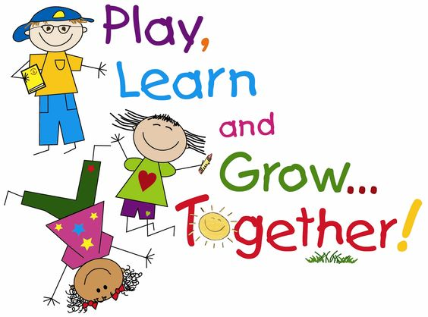
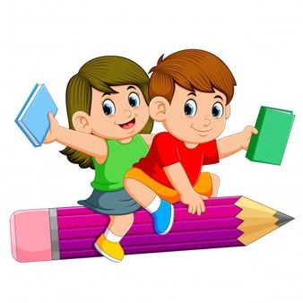
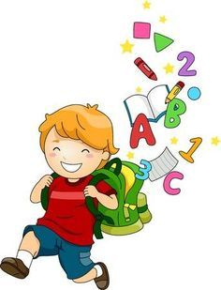

GREENWOOD PUBLIC SCHOOL
ADITYAPURAM, GWALIOR
SESSION 2026-27 : SYLLABUS FOR THE MONTH OF APRIL : CLASS-UKG
SUBJECTS | SYLLABUS | ACTIVITY + USE OF ICT | PARENTS INVOLVEMENT
ENGLISH | ORAL:  Rhymes-  1. Little Boy, Sunny  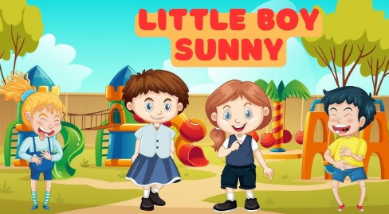  2. Traffic Lights    Sentence Structure-  1. I study in UKG class.  2. The name of my school is Greenwood Public School.  Reading (Phonics Skill Book)-  Page no. 3, 4  Vocabulary Building- Summer, Hot, Holiday, Girl, Boy, Bag, Book  WRITTEN:  Small Cursive Letters a-z, Capital Cursive Letters A-Z | Little Boy, Sunny  https://www.youtube.com/watch?v=q6OrqLv3U78  Traffic Lights  https://www.youtube.com/watch?v=HhrfOgLjBvg&list=RDHhrfOgLjBvg&start_radio=1  Phonics Sound  https://www.youtube.com/watch?v=hq3yfQnllfQ  Vowels Song  https://www.youtube.com/watch?v=RUSCz41aDug  Sound of ‘a’  https://www.youtube.com/watch?v=Sno15qcDEr4  Activity Work  - ‘Read and Tell’ Game will be played for the three letters words. Learners will be asked to read the words as shown by the teacher. | - Play music and encourage your child to dance around. When the music stops, call out a word that rhymes with a simple action (e.g., "Little Boy" and "Traffic Lights"). Children freeze in place and perform the action associated with the rhyming word.

SUBJECTS | SYLLABUS | ACTIVITY + USE OF ICT | PARENTS INVOLVEMENT
HINDI | dfork,¡&  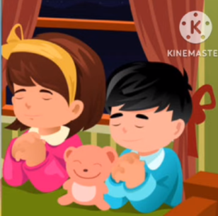  1- eq>dks 'kfDr nks Hkxoku  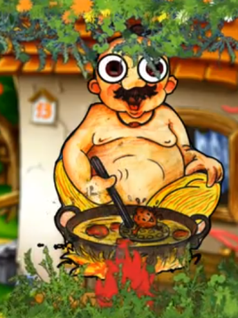  2- idkSM+h dh dgkuh  iBu ikBu& v ls v% rd] ist ua 4  okD; jpuk& eSa ;w-ds-th- d{kk esa i<+rk@i<+rh gw¡A]  eSa xzhuoqM ifCyd Ldwy esa i<+rk@i<+rh gw¡A  fyf[kr%&  Loj o.kZ& v ls v% rd]  O;atu& d ls K rd | eq>dks 'kfDr nks Hkxoku  https://www.youtube.com/watch?v=PGbaEM3A324&list=RDPGbaEM3A324&start_radio=1  idkSM+h dh dgkuh  https://www.youtube.com/watch?v=A_CMAzTz_aI  o.kZekyk  https://www.youtube.com/watch?v=GBWGNvHsiFs  nks v{kj okys “kCn  https://www.youtube.com/watch?v=eiiahBq5Zt0  Activity Work  - dforkvksa dks lLoj okpu  - ns[kks vkSj crkvksaÞ [ksy ls fp=ksa dks  igpkudj crk,¡A  - ^ns[kksa vkSj crkvks* [ksy ds tfj, fcuk ek=k okys “kCnksa dks if<+, ,oa crkb,sA | - cPpksa dks fcuk ek=k okys “kCn dks i<+us esa lgk;rk djsaA  - cPpksa dks dfork fofHkUu Hkkoksa rFkk eqnzkvksa lfgr ;kn djkus ds fy, çksRlkfgr djsaA

SUBJECTS | SYLLABUS | ACTIVITY + USE OF ICT | PARENTS INVOLVEMENT
Numeracy & Skill book & Workbook | 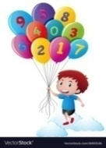  ORAL:  1. Counting from 1-50  2. Tables of 2  3. Number names from 1 to 10  4. Shapes Names  WRITTEN:  Counting from 1 to 50,  Missing Numbers,  Number names from 1 to 10,  Table of 2,  Before, After, Between,  Count and Write,  Matching Shapes | Counting-  https://www.youtube.com/watch?v=B5iAW-jnkPw  Table of 2-  https://www.youtube.com/watch?v=VKJ9cCQgPdc  Number Names  https://www.youtube.com/watch?v=LyvQ6pc7JSA  Activity Work  - ‘Look and Identify’ Number Game  - ‘Count and Tell’ Game. Learners will be asked to count the objects asked by the educator.  - ‘Dodging’ Game from the table of 2 and 3 | - Provide a variety of toys or objects (e.g., blocks, stuffed animals). Ask your child to count the toys, group them by number, or sort them into containers labeled with numbers.
EVS  General Awareness Skillbook  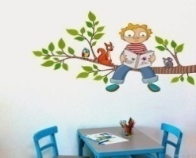 | ORAL:  1. Parts of Body  2. Fruits Names  WRITTEN:  1. Body Parts  2. Fruits Names  (Tick the correct option, Matching, fill in the blanks) | Body Parts  https://www.youtube.com/watch?v=SUt8q0EKbms  Fruits Names  https://www.youtube.com/watch?v=DiV48J0uB_Y | - Sit in front of a mirror with your child and take turns mimicking each other's movements. Encourage them to point to and name the body parts they are moving.
  ART & CRAFT | Page no. 3 to 5  Craft- Clown Making  Theme-Shapes | Activity Work  - ‘Look and Identify’ Shapes Game  - ‘Cut and Paste’ Game of different objects. | - Provide play dough and shape cutters in various shapes (e.g., circles, squares, triangles). Encourage your child to roll out the play dough and use the cutters to make shapes.
GENERAL KNOWLEDGE | Colours Names   | Colours Names  https://www.youtube.com/watch?v=vzcpnziBHcU  Activity Work  - Make a Colour Paper Collage using  coloured sheets. Theme-Rainbow | - Take your child to a local fruit market where children can see a wide variety of fruits firsthand. Allow them to interact with vendors, ask questions and learn about different fruits.

SUBJECTS | SYLLABUS | ACTIVITY + USE OF ICT | PARENTS INVOLVEMENT
VALUE EDUCATION | Obey your elders | Moral Story- Obey your elders, Learning to Obey  https://www.youtube.com/watch?v=ziXvFCKEGqM  https://youtu.be/BjrKiRNr8cw?feature=shared | - Tell any story to your child as a tool to convey the importance of obeying elders.
PHYSICAL EDUCATION | Fun Games- Running, Jumping, Hopping, Yoga | DO EXERCISE THROUGH THIS LINK  https://www.youtube.com/watch?v=JoF_d5sgGgc | - Take your child to a park and play some games.
DANCE  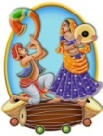 | 1. Welcome Song,  2. Deep Deep Deep | Welcome Song  https://youtu.be/Iskpu8586Ek?si=LQgyxxdoKR60PT8Y  Deep Deep Deep  https://youtu.be/oZhwagxWzOc?feature=shared | - Encourage your child to move specific body parts independently, such as wiggling fingers or shaking hips.
MUSIC | National Anthem, Gayatri Mantra | National Anthem  https://www.youtube.com/watch?v=RqQ4asI70Bg  Gayatri Mantra  https://www.youtube.com/watch?v=SPm-Qy5m39E  Hanuman Chalisa  https://www.youtube.com/watch?v=iI77p-PPAxs | - Practice the prayer regularly with your child to memorize it.
MOTOR SKILL DEVELOPMENT | 1. How to do Namaste  2. How to walk in a straight line  3. How to sit gracefully on the chair  4. How to use the washroom and wash hands | REFER THIS LINK  https://www.youtube.com/watch?v=wh6gt3IkRKk | - Encourage your child to run around in open spaces, either indoors or outdoors.
LANGUAGE DEVELOPMENT | Welcome to the class!,  Nice to meet you!,  Have a nice day! | Good Habits  https://youtu.be/mbv63Lz2vAw?feature=shared | - Encourage your child to engage in role-playing activities and act like different characters.
S.T.E.M. Fun | Melting Ice:  - Materials: Ice cubes, salt, small plastic toys  - Procedure: Place ice cubes in a container and sprinkle salt over some of them. Encourage children to observe and compare how the ice cubes melt with and without salt. Add small plastic toys to the ice cubes and observe how the melting ice affects them.
CONVERSATION | ENGLISH CONVERSATION  1. What is your name?  Ans. My name is .  2. What is your father’s name?  Ans. My father’s name is .  3. What is your mother’s name?  Ans. My mother’s name is .  4. How old are you?  Ans. I am … years old.  5.What is the name of your school?  Ans. The name of my school is Greenwood Public School. | HINDI CONVERSATION  1- vkidk D;k uke gS\  m& esjk uke gSA  2- vkids firkth dk uke D;k gSa\  m& esjs firkth dk uke Jh gSA  3- vkidh ekrkth dk uke D;k gSa\  m& esjh ekrkth dk uke Jherh gSA  4- vki fdrus o’kZ ds gSa\  m& eSa o’kZ dk gw¡A  5- vkids fo|ky; dk D;k uke gS\  m& esjs fo|ky; dk uke xzhuoqM ifCyd Ldwy gSA | 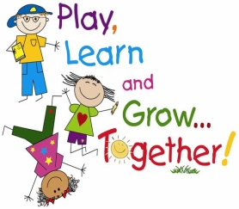  - Pay close attention to your child when he/she speaks, and respond with interest and enthusiasm. Ask open-ended questions and let the child respond.
10th April- Rhymes Recitation, Baisakhi Celebration,
22nd April- Earth Day Celebration- Handband Making using leaves

